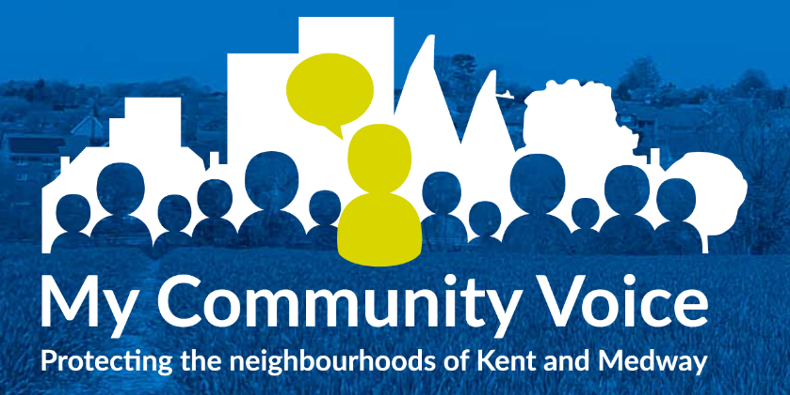

Kent Police – New Community Interactive 2 Way Messaging Service
My Community Voice is a new and exciting two-way messaging service that helps Kent and Medway residents, businesses, and community groups to keep in touch with their local policing teams. The service sends updates about your local area directly from the police officers themselves.
My Community Voice is more than just a messaging service; it allows you to reply to the alerts sent by Kent Police, share information and most importantly, it allows you to tell the police about issues that are affecting you.
You will be able to play an active part in police appeals as well as being kept up to date with what is happening in your local area.
Unlike social media, My Community Voice is a secure and personal messaging system that allows you to determine what type of alerts you receive and how.
If you are passionate about your neighbourhood and want to have your voice heard, then sign up to My Community Voice via the QR code below.

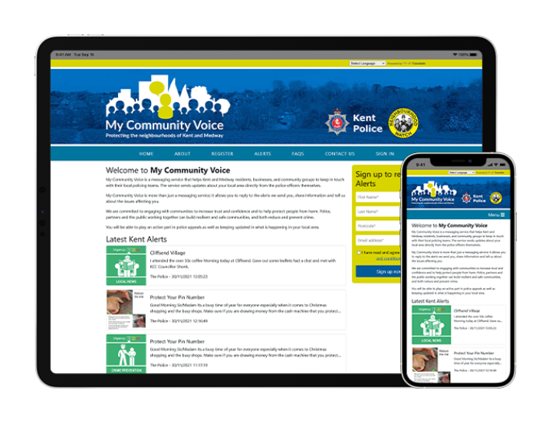
My Community Voice allows you to comment by clicking the 'reply' link within a message. This will be sent back to the person that posted the alert. All emails are read and actioned. This service should not be used as a crime reporting tool. Please use www.kent.police.uk/report or in an emergency, if a crime is in progress or life is in danger, call 999.
Sign up today to start getting alerts about the matters that mean the most to you such as community safety, anti-social behaviour, including speeding and many others. Kent Police are committed to engaging with communities, understanding what’s important to them, increasing trust and confidence and helping to protect people from harm. Police, partners, and the public working together can build resilient and safe communities, and both reduce and prevent crime. Sign up to My Community Voice now to keep up to date with what is really happening in your area.
www.mycommunityvoicekent.co.uk

